**Leaf classification based on Wavelet Transform and Gaussian interpolation**

**Md.Rasheduzzaman**

**ID: 0910647044**

**CSE-468**

**(rashed091nsu@gmail.com)**

**Abstract** - In this paper, we employ wavelet transformation and Gaussian interpolation to find the skeleton of leaf and then using gray level run-length feature technique to extract texture features of leaves. After that we used a nearest neighbor classifier (1-NN), a *k*-nearest neighbor classifier (k-NN), to recognize the leaves from extracted features.

**Keywords** – Wavelet transform (WT), Haar wavelet, Gaussian interpolation, Gray Level Run Length Matrix (GLRL), 1-NN, K-NN

**1. Introduction**

Plants are everywhere around us, even in the place where we human can’t possibly reach. Plant classification is general purpose of botanical science, forestry and agriculture. The ability to identify plant materials is an important skill for people who are interested in horticulture, forestry, landscape architecture, parks and recreation, botany, and a number of other career areas. Plant identification has evolved over hundreds of years and depends to a large extent on what criteria and whose system is used. Plants can be classified using structures of stems, roots and leaves, embryology and flowers. We are interested in designing an automated system that can easily identify Plants using leaves. In this paper we designed a system in combination of wavelet transformation and Gaussian interpolation.

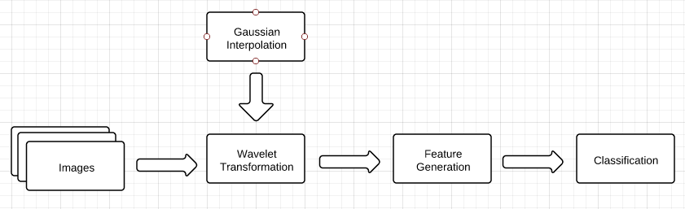

Figure: System structure

**2. Related Work**

Most recent work in leaf recognition system has used a shape modeling approaches that relies on Moment-Invariant (M-I) and Centroid-Radii (C-R) model proposed by Jyotismita and Ranjan [1]. This approach is attractive because it uses both 2-D and 3-D feature space for producing optimal result. The C-R model uses an edge detector to fine the skeleton of the leaf and feature vector produce by 36 radii at 10 degree angular separation. Then it uses the Neural Network to classify the leaf. For their experiment Jyotsmita and ranjan used 180 images of three classes each with 60 images. The accuracies of their proposed model varies from 90%-100%. In contrast our wavelet based model uses 2-D discrete Haar wavelet and Gaussian interpolation to find the leaf skeleton. Another group of researcher proposed a model using probabilistic neural network. Stephen and Forrest [2] employ Probabilistic Neural Network (PNN) for plant classification. It uses 12 commonly used digital morphological features (DMFs) with 5 basic geometric features as an input for their network. Then it uses Principal Component Analysis (PCA) to reduce the dimension of input vector of neural network. The PNN is trained with 1800 leaves to classify 32 kinds of plants with accuracy greater than 90%. Another method proposes by Bama and Valli [3], uses the leaf images shape, color and texture for the leaves classification. First it uses HSV color space to enhance the leaves. Then it uses Log Gabor wavelet to extract texture feature. Then it uses Scale Invariant Feature Transform (SIFT) to find the key points of the leaves at different scale which is than compared with other leaf images to find the best match. Bama and Valli used 500 leaf images which belong to 45 different types of plant for their experiment. Their proposed method archives accuracy around 97.9%.

**3. Problem definition and Algorithm**

The main objective of this paper is to develop a leaf classification system that can classify plants based on it leaves. For these we have employed the wavelet decomposition with Gaussian interpolation. For the classification we have used statistical classification algorithm nearest neighbors.

**4. Wavelet Transforms**

Wavelets are mathematical function that satisfy certain properties and can used to transform one function representation into basis functions like the Haar or Daubechies wavelet. The major advantage of using wavelet is that they can be used for analyzing function at various scales, such as multi-resolution, versions of an image at various resolutions, just like human eye. In practice, the wavelet transforms have great advantage over the traditional Fourier methods in analyzing signals, which contain discontinuities and sharp spikes like mote natural images. Wavelet analysis produces a time-scale view of the signal by stretching or compressing the signal. Wavelet transform decomposes a signal into set of basis function. These basis functions are called wavelets. Wavelets are obtained from a single prototype wavelet $ψ(t)$ called mother wavelet by dilations and shifting. The mathematical representation of the 1D wavelet function is:

$ψ_{a,b}\left(t\right)=\frac{1}{\sqrt{a}}ψ\left(\frac{t-b}{a}\right)$

and 2D function is:

$ψ_{a,bx,by}\left(x,y\right)=\frac{1}{\left|a\right|}ψ\left(\frac{x-bx}{a}-\frac{y-by}{a}\right)$

where $a$ is the scaling parameter and $b$ is the shifting parameter. The discrete wavelet transform of an image, $I=A_{0}=f\left(x,y\right)$ of size $M×N$ is then:

$W_{ϕ}\left(j_{0},m,n\right)=\frac{1}{\sqrt{MN}}\sum_{x=0}^{M-1}{\sum_{y=0}^{N-1}{f(x,y)}}ϕ_{j_{0},m,n}\left(x,y\right)$

$W_{ψ}^{i}\left(j,m,n\right)=\frac{1}{\sqrt{MN}}\sum_{x=0}^{M-1}{\sum_{y=0}^{N-1}{f(x,y)}}ψ_{j,m,n}^{i}\left(x,y\right), i=\left\{H,V,D\right\}$

where $H$ prepresents the Horizontal components, $V$ the Vertical components and $D$ the Diagonal components. Single level wavelet decomposition is shown in the figure below

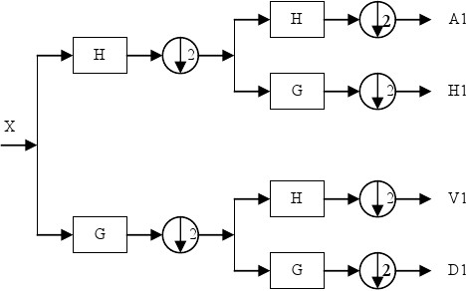

Figure: single level WT

The input signal is passed through a high pass and low pass filter. Then the filtered signal is down sampled by two, by simply throwing away every second coefficient.

**5. Feature Generation**

The feature generation stage is the process of computing feature from an image or from a region of within the image to be used in the classification task. The generated feature must encode this kind of information in order to enhance the classification accuracy. In our project we used gray level run-length matrix feature.

**5.1. Gray Level Run-length Matrices**

The run length matrix encodes textural information based on the number of each gray level appears in the image by itself [5]. A set of consecutive, pixels with the same gray level, collinear in a given direction, constitute a gray level run. The run-length is the number of pixel in the run, and the run-length value is the number of times such a run occurs in an image. Let an image array $I(m,n)$ with 4 gray levels and its corresponding gray level run-length matrices $P(i,j|θ=0^{0})$ is illustrated below.

IMAGE

|  |  |  |  |
| --- | --- | --- | --- |
| 1 | 2 | 3 | 4 |
| 1 | 3 | 4 | 4 |
| 3 | 2 | 2 | 2 |
| 4 | 1 | 4 | 1 |

(a)

|  |  |  |  |  |
| --- | --- | --- | --- | --- |
| Gray level  i | Run length (j) | | | |
| 1 | 2 | 3 | 4 |
| 1 | 4 | 0 | 0 | 0 |
| 2 | 1 | 0 | 1 | 0 |
| 3 | 3 | 0 | 0 | 0 |
| 4 | 3 | 1 | 0 | 0 |

(b)

Figure 1.(a) Image array with 4 gray levels. (b) Computation of run-length matrices for $P(i,j|θ=0^{0})$

Each matrix element specifies the number of times that the picture contains a run of length (1….4) in the given direction. The first element of the first row of the matrix is number of times gray level ‘0’ appears by itself, the second element is number of times it appears in pairs and so on. In same way mention above we can calculate the corresponding run-length matrix for other direction (0, 45, 90, and 135).

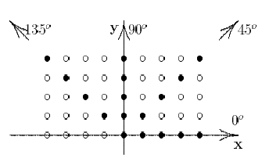

Figure 2: Geometry for measurement of gray level run length Matrix for 4 angles.

Different number of texture features can be computed from the gray level from run-length matrices. Galloway 1975[5] introduced five statistical texture features to be extracted from the gray level run-length matrices and later Chu et al. (1990) introduce two additional features namely Low Gray Level Run Emphasis (LGRE) and High Gray Level Run Emphasis (HGRE). The textural feature that can be extracted from the run length matrices are presented below:

1. Short Run Emphasis (SRE): $SRE=\frac{\sum_{i=1}^{G}{\sum_{j=1}^{R}{\frac{P(i,j|θ)}{j^{2}}}}}{\sum_{i=1}^{G}{\sum_{j=1}^{R}{P(i,j|θ)}}}$

Where $P(i,j|θ)$ is the run length matrix, G is the number of gray levels in the image, R is the largest possible run $(i=1,…,G, j=1,…,R)$. SRE tends to emphasis short runs due to the division with.

2. Long Run Emphasis (LRE): $LRE=\frac{\sum_{i=1}^{G}{\sum_{j=1}^{R}{j^{2}P(i,j|θ)}}}{\sum_{i=1}^{G}{\sum_{j=1}^{R}{P(i,j|θ)}}}$

LRE tends to emphasis long runs. Here we multiply each run length values by the square of its length, in order to give higher weight to the long runs.

3. Gray Level Non Uniformity (GLNU): $GLNU=\frac{\sum_{i=1}^{G}{{\left(\sum_{j=1}^{R}{P(i,j|θ)}\right)}^{2}}}{\sum_{i=1}^{G}{\sum_{j=1}^{R}{P(i,j|θ)}}}$

GLNU is proportional with large run length values that are uniformly distributed.

4. Run Length Non Uniformity (RLNU): $RLNU=\frac{\sum_{j=1}^{R}{{\left(\sum_{i=1}^{G}{P(i,j|θ)}\right)}^{2}}}{\sum_{i=1}^{G}{\sum_{j=1}^{R}{P(i,j|θ)}}}$

RLNU encodes long runs that are non-uniformly distributed. If the runs are evenly distributed then it will have lowest value.

5. Run Percentage (RP): $RP=\frac{1}{n}\sum_{i=1}^{G}{\sum_{j=1}^{R}{P(i,j|θ)}}$

Where, $n$ is the total number of runs in the input image, this feature is the ratio between the total number of observed runs in the image and the total number of possible runs.

6. Low Gray Level Run Emphasis (LGRE):

7. High Gray Level run Emphasis (HGRE): $HGRE=\frac{\sum_{i=1}^{G}{\sum_{j=1}^{R}{i^{2}P(i,j|θ)}}}{\sum_{i=1}^{G}{\sum_{j=1}^{R}{P(i,j|θ)}}}$

Both LGRE and HGRE feature make use of the gray level of the runs, and are introduced in order to distinguish textures that are similar according to their SRE and LRE features, but differ in gray level distribution of the runs.

**6. The Algorithm**

Before going to the experimental stage we describe how the whole system will work with wavelet transform combined with the Gaussian interpolation. The algorithm proposed in this paper has two parts. The structure of our algorithm is given below

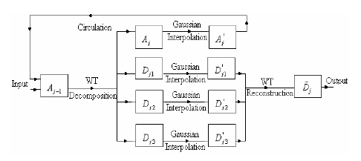

Figure: Block diagram of the Wavelet transform

**Part 1: Skeleton segmentation stage**

Step 1: Input the original leaf’s image $I$

Step 2: if $I$ is color image, then convert it into a gray scale image and denote it as $I=A_{0}$

Step 3: set the parameter of WT, like the level of WT, wavelet’s name and its corresponding coefficients. Denote the variable for circulation as $j$, and let $j=1$

Step 4: Decompose $A_{j-1}$ to get the images $\left(A_{j},D_{j1},D_{j2}{,D}_{j3}\right)$ by WT

Step 5: Add Gaussian interpolation with $\left(A_{j},D_{j1},D_{j2}{,D}_{j3}\right)$

Step 6: Reconstruct $D_{j1},D_{j2}$ and $D_{j3}$ to get the image os the leaf’s skeleton $D_{j}$

**Part 2: Feature extraction stage**

Step 6: Extract the run-length features (SRE, LRE, GLN, RLN, RP, LGRE and HGRE) from the image $D_{j}$ and save these features in some file.

Step 7: If j equal to the parameter of levels of WT, turn to step 8 otherwise let $j=1+1$, and then turn to step 4

Step 9: End, and output the data file which saves the features.

**7. Experiment and Result**

All the experiments are programmed in Matlab 2012a and on core i7 machine under windows 7. Sample leaf images were collected from 5 different plants. Each plant has 20 images. Our data set contains total 100 sample images. From these 100 images we used 10 images from each plant for training and another 10 for testing.

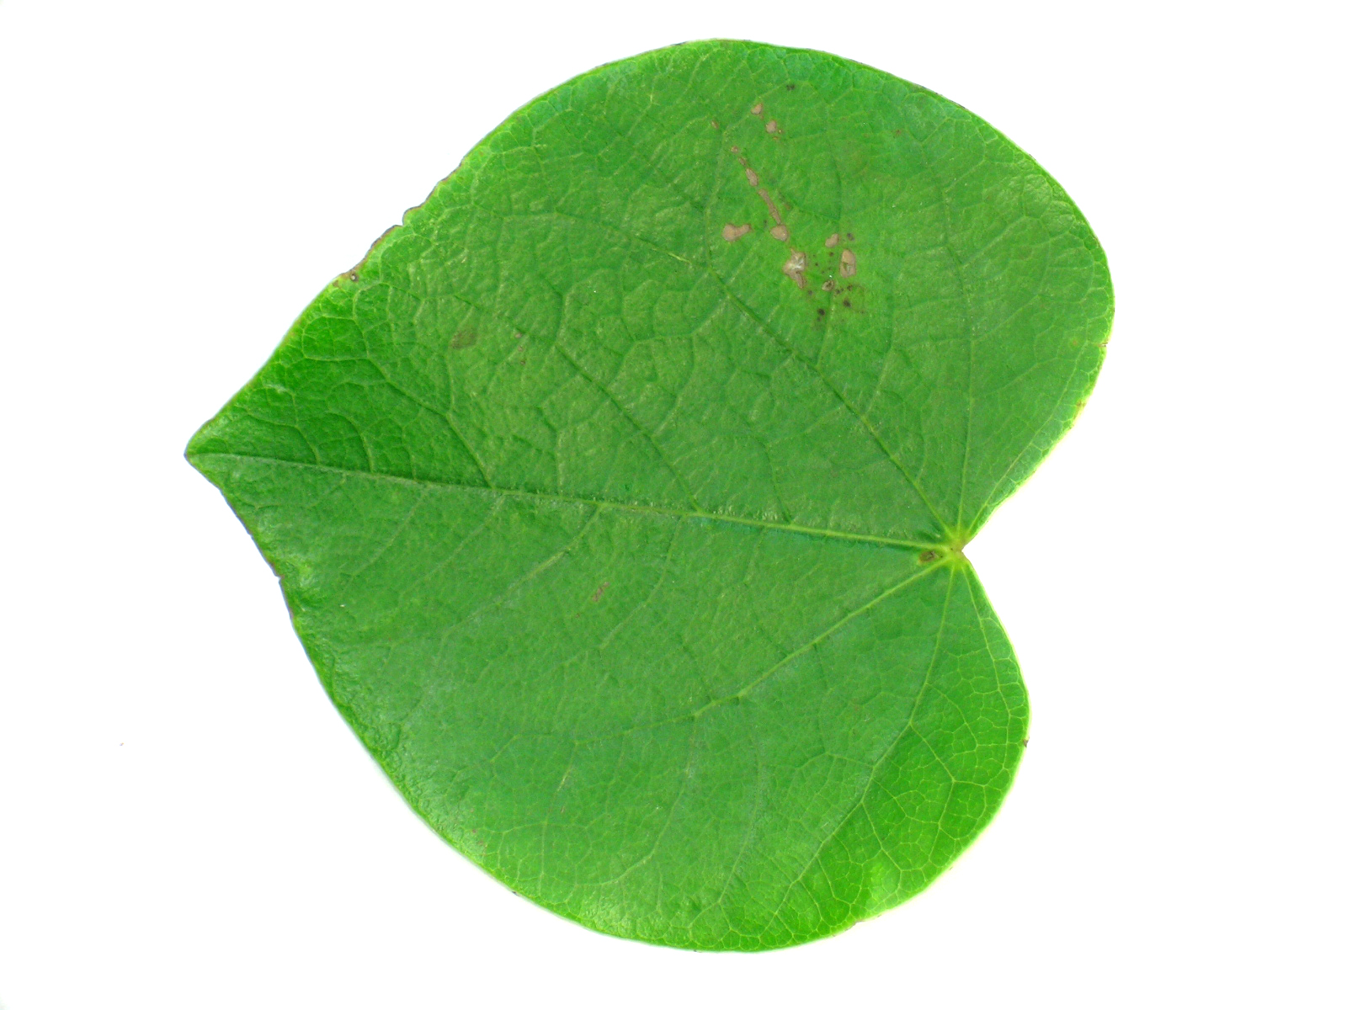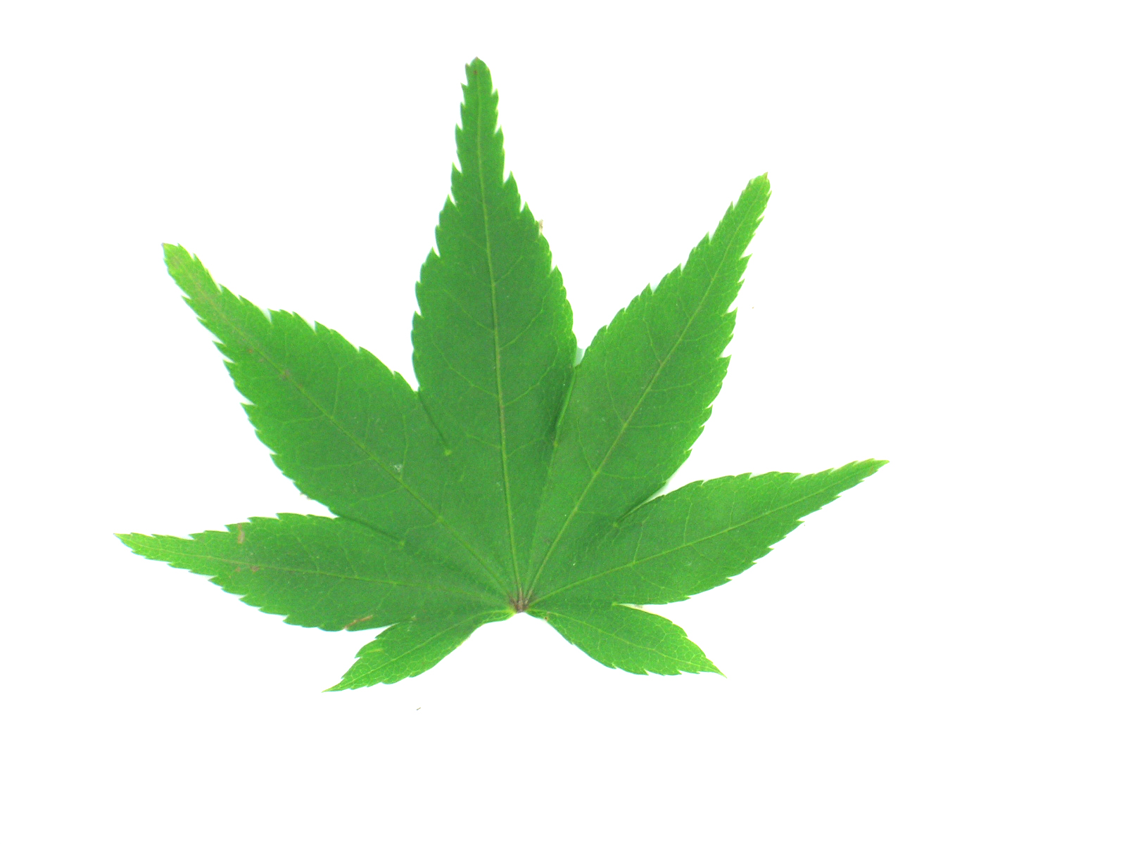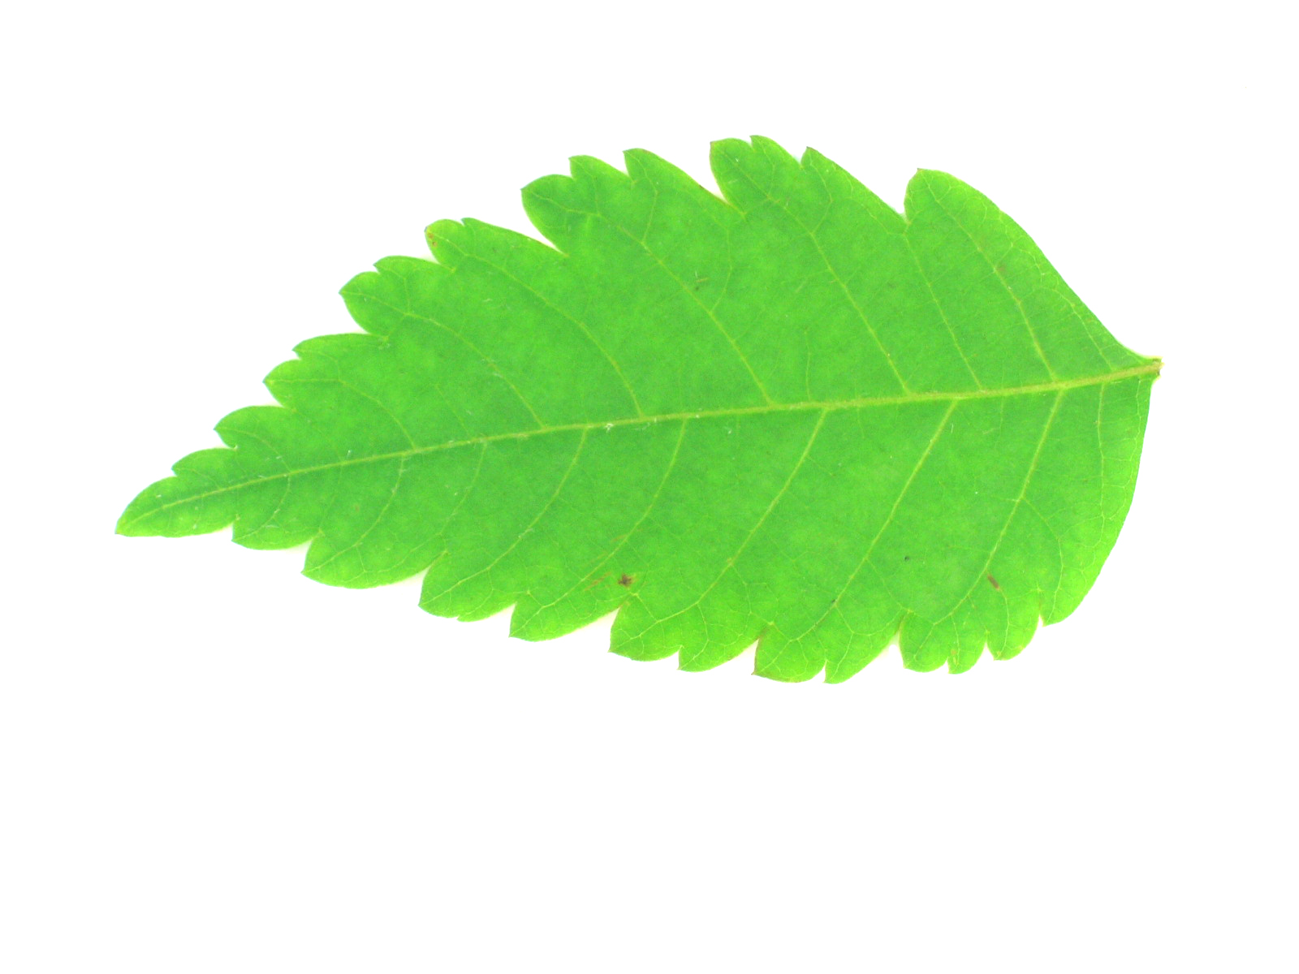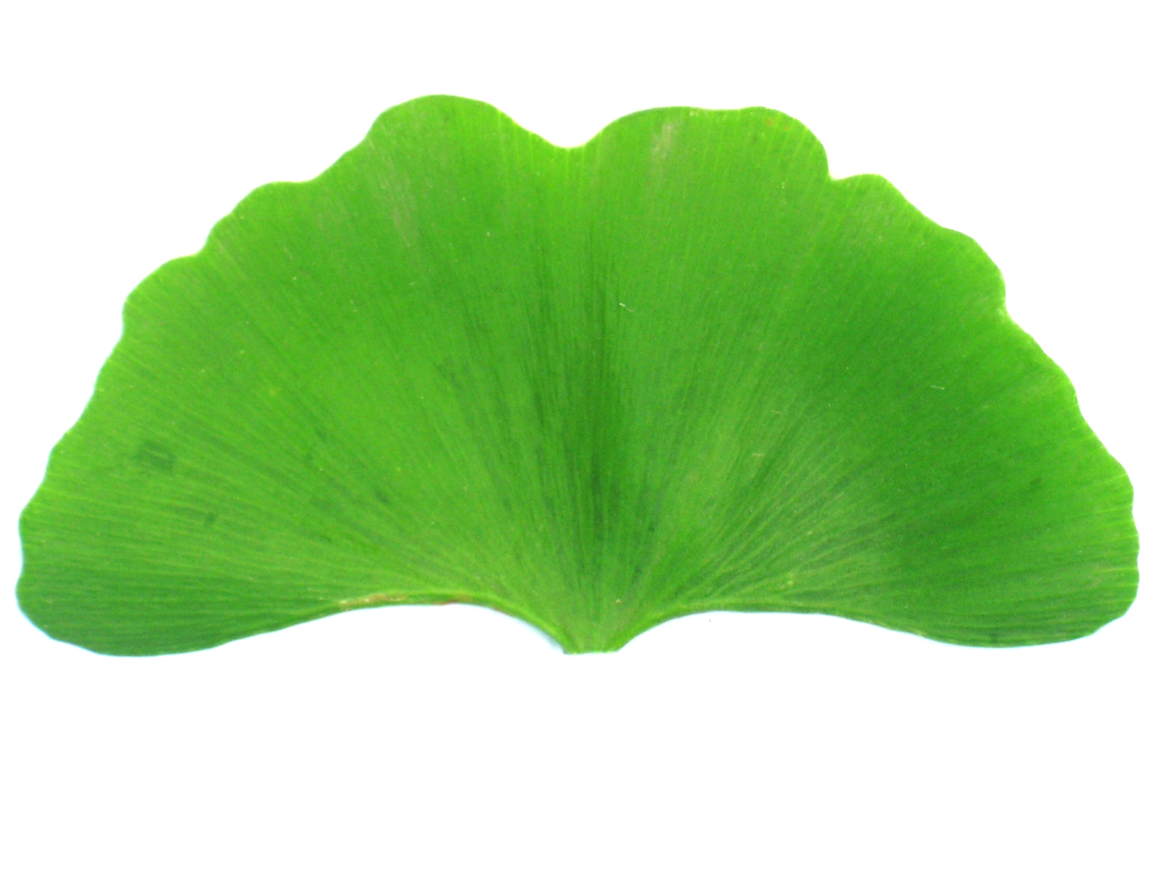

Figure: Sample Leaf images

Before the processing stages (wavelet, feature generation and classifier) all the images were convert from RGB color space into gray scale color space. The pre-processing stage is the stage before entering the images in the wavelet decomposition and reconstruction. Its role is to prepare the data for the processing stages (wavelet transform, feature generation and classifier). In the wavelet transform stage all the gray scale images were decomposed by the WT in 3 levels.

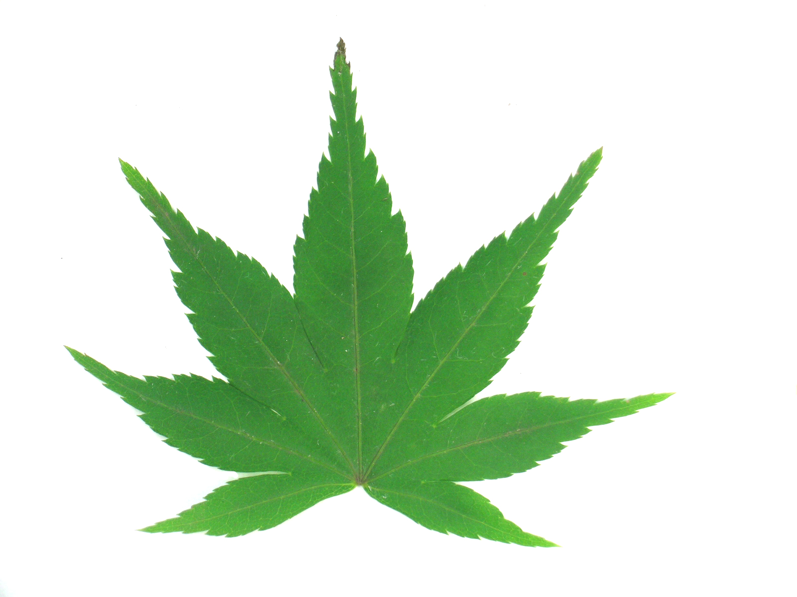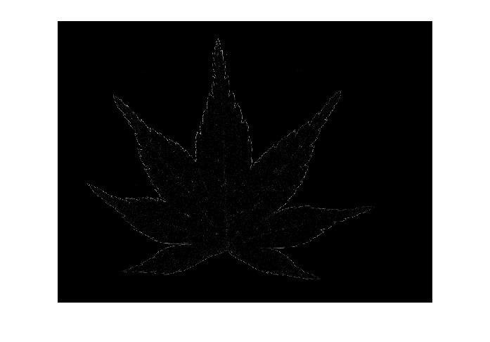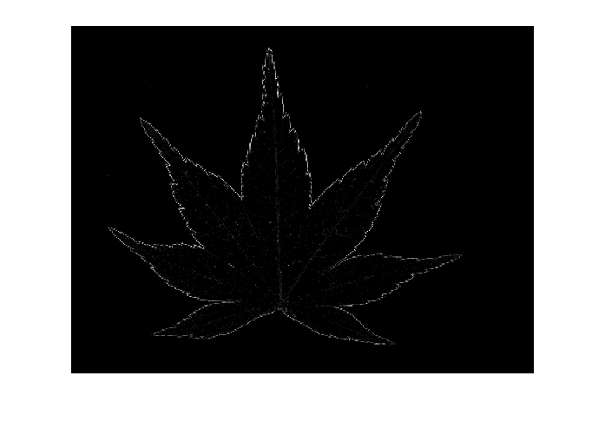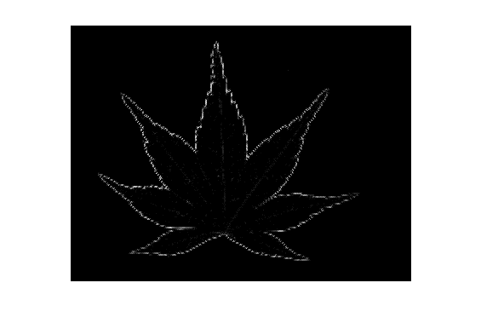

Figure: 3 level of decomposition using WT

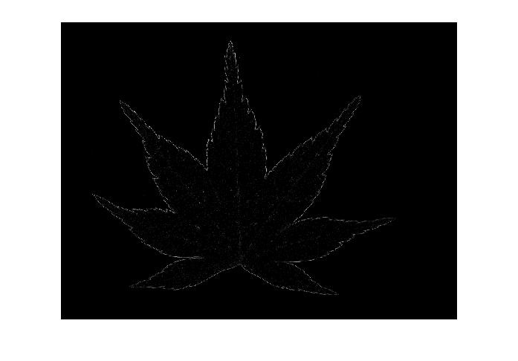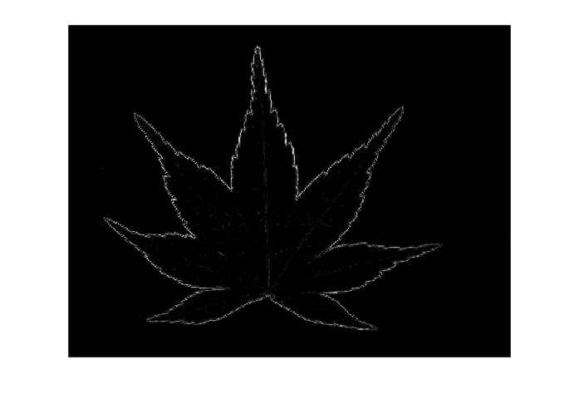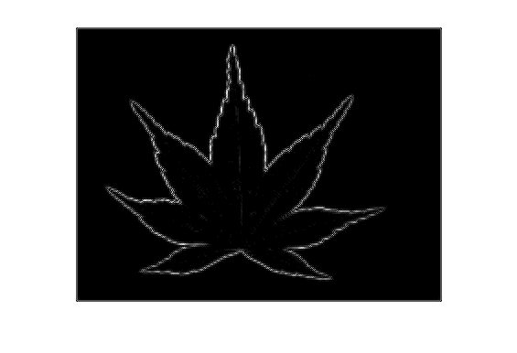

Figure: 3 level of WT images with added Gaussian interpolation

In order to enhance the skeleton of the leaf image, we added Gaussian interpolation with decomposed image. After the segmentation of the leaf’s skeleton, from reconstructed detail images $D_{j}$, $84 (7×4×3)$ run-length feature were extracted. After computing feature vector for all the images, $K^{th}-nearest neighbors$ statistical classification algorithm is used for classification and recognition of the leaf images. In the figure given below, the correct rate of using only WT for leaf recognition is 82 percent and with added Gaussian interpolation the correct rate is 84 percent.

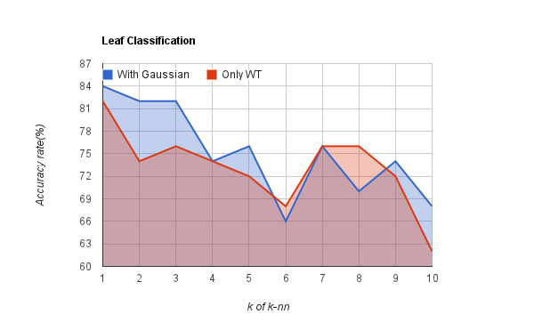

Figure: $k vs. average accuracy rate(\%)$

If look carefully at the graph we can see that the performance of the WT with Gaussian is better than only WT and also we see that as we increase the number of neighborhood the performance of our classification algorithm decreases in both cases.

|  |  |  |
| --- | --- | --- |
| Classifiers | 1-NN | K-NN |
| Accuracy rate(%) | 84 | 82 |

Figure: The Performance table

**8. Conclusions**

In this we have employed the wavelet decomposition and Gaussian interpolation method. The wavelet decomposition successfully separate the skeleton of leaf’s and Gaussian interpolation enhance the skeleton which lead to increasing performance. Then, run-length feature were used to generate the feature and statistical classification algorithm nearest neighbor in use to correctly classify the leaves.

**9. Reference**

1. J. chaki and R. Parekh, Plant leaf recognition using shape based feature and Neural Network classifier

2. S. Gang and F. Bao, A leaf recognition algorithm for plant classification using Probabilistic Neural Network

3. B. Sathya Bama and S.Mohana Valli, content based leaf image retrival using Shape, color and Texture feature

4. N. Jacob and A. Martin, Image denoising in the wavelet domain using wiener filtering

5. M. Misiti and Y. Misiti, Wavelet and their application

6. M. Samulski, Compression of images, fourier and wavelet

7. Gonzalez and Woods, digital image procession, 3rd edition

8. F. Albregtsen, Statistical Texture measures computed from Gray level run length matrices

**10. Code**

|  |
| --- |
| **Gray Level run Length Matrix** |
| function [F0,F45,F90,F135]=glrl(I)  [r,c] = size(I);  level=16;  F0 = zeros(r,c); % 0 degree feature  F45 = zeros(r,c); % 45 degree feature  F90 = zeros(r,c); % 90 degree feature  F135 = zeros(r,c); % 135 degree feature  I0 = I; % temp image for 0 dergree  I45 = I; % temp image for 45 degree  I90 = I; % temp image for 90 degree  I135 = I; % temp image for 135 degree    % calculating 0 degree gray level run-length feature  count = 0;  for i=1:r  for j=1:c  cur=I0(i,j); % current gray level  count=count+1; % number of time current gray level appears in the image along 0 degree  TF=check(i,j+1,r,c); % check index out of bound  if(TF==1 && I0(i,j+1)==cur)  continue;  else  F0(cur,count) = 1 + F0(cur,count);  count=0;  end  end  end  % calculating 45 degree gray level run-length feature  count = 0;  for i=r:-1:1  for j=c:-1:1  cur=I45(i,j); % current gray level  if(cur==-1)  continue;  end  count=count+1; % number of time current gray level appears in the image along 45 degree  I45(i,j)=-1;  m=i-1;  for n=j+1:1:c  TF=check(m,n,r,c); % check index out of bound  if(TF==1 && I45(m,n)==cur)  count=count+1;  I45(m,n)=-1;  else  break;  end  m=m-1;  end  F45(cur,count) = 1 + F45(cur,count);  count=0;  end  end  % calculating 90 degree gray level run-length feature  count = 0;  for i=r:-1:1  for j=c:-1:1  cur=I90(i,j); % current gray level  if(cur==-1)  continue;  end  count=count+1; % number of time current gray level appears in the image along 90 degree  I90(i,j)=-1;  n=j;  for m=i-1:-1:1  TF=check(m,n,r,c); % check index out of bound  if(TF==1 && I90(m,n)==cur)  count=count+1;  I90(m,n)=-1;  else  break;  end  end  F90(cur,count) = 1 + F90(cur,count);  count=0;  end  end  % calculating 135 degree gray level run-length feature  count = 0;  for i=r:-1:1  for j=1:c  cur=I135(i,j); % current gray level  if(cur==-1)  continue;  end  count=count+1; % number of time current gray level appears in the image along 135 degree  I135(i,j)=-1;  m=i-1;  for n=j-1:-1:1  TF=check(m,n,r,c); % check index out of bound  if(TF==1 && I135(m,n)==cur)  count=count+1;  I135(m,n)=-1;  else  break;  end  m=m-1;  end  F135(cur,count) = 1 + F135(cur,count);  count=0;  end  end  %resize features  F0=F0(1:level,:);  F45=F45(1:level,:);  F90=F90(1:level,:);  F135=F135(1:level,:);  % End of function  end    function R=check(i,j,r,c)  if(i>0 && i<=r && j>0 && j<=c)  R=1;  else  R=0;  end  end |

|  |
| --- |
| **Feature Generation** |
| % This function calculates Gray level feature  % intorduced by Galloway (1975) and Chu et al.(1990)  function [SRE,LRE,GLN,RLN,RP,LGRE,HGRE]=glrlFeature(F)    [r,c] = size(F);  % Short Run Emphasis (SRE)  SRE = 0;  temp = 0;  for i = 1:r  for j = 1:c  SRE = SRE + (F(i,j)/j^2) ;  temp = temp + F(i,j);  end  end  SRE = SRE / temp;  % End of SRE    % Long Run Emphasis (LRE)  LRE = 0;  temp = 0;  for i = 1:r  for j = 1:c  LRE = LRE + (F(i,j)*j^2) ;  temp = temp + F(i,j);  end  end  LRE = LRE / temp;  % End of LRE    % Gray Level Non-uniformity (GLN)  GLN = 0;  temp = 0;  for i = 1:r  for j = 1:c  GLN = GLN + (F(i,j)^2) ;  temp = temp + F(i,j);  end  end  GLN = GLN / temp;  % End of GLN    % Run Length Non-uniformity (RLN)  RLN = 0;  temp = 0;  for j = 1:c  for i = 1:r  RLN = RLN + (F(i,j)/j^2) ;  temp = temp + F(i,j);  end  end  RLN = RLN / temp;  % End of RLN    % Run Percentage (RP)  RP = 0;  temp = r*c;  for i = 1:r  for j = 1:c  RP = RP + F(i,j) ;  end  end  RP = RP / temp;  % End of RP    % Low Gray Level Runs Emphasis(LGRE)  LGRE = 0;  temp = 0;  for i = 1:r  for j = 1:c  LGRE = LGRE + (F(i,j)/i^2) ;  temp = temp + F(i,j);  end  end  LGRE = LGRE / temp;  % End of LGRE    % High Gray Level Runs Emphasis (HGRE)  HGRE = 0;  temp = 0;  for i = 1:r  for j = 1:c  HGRE = HGRE + (F(i,j)*i^2) ;  temp = temp + F(i,j);  end  end  HGRE = HGRE / temp;  % End of HGRE  end |

|  |
| --- |
| **Haar Wavelet** |
| function [R1,R2,R3]=haarWavelet(I)  I=rgb2gray(I);  % level 1 decomposition  [I1,H1,V1,D1]=dwt2(I,'haar');  [I1,H1,V1,D1]=gaussF(I1,H1,V1,D1);  % level 2 decomposition  [I2,H2,V2,D2]=dwt2(I1,'haar');  [I2,H2,V2,D2]=gaussF(I2,H2,V2,D2);  % level 3 decomposition  [I3,H3,V3,D3]=dwt2(I2,'haar');  [I3,H3,V3,D3]=gaussF(I3,H3,V3,D3);  % data reconstruction  R1=idwt2([],H1,V1,D1,'haar');  R2=idwt2([],H2,V2,D2,'haar');  R3=idwt2([],H3,V3,D3,'haar');    R1=wcodemat(R1);  R2=wcodemat(R2);  R3=wcodemat(R3);  end    function [I,H,V,D]=gaussF(I,H,V,D)  f=fspecial('gaussian',5);  I=imfilter(I,f);  H=imfilter(H,f);  V=imfilter(V,f);  D=imfilter(D,f);  end    function I=makeZ(I)  I=round(I);  [r,c]=size(I);  for i=1:r  for j=1:c  if(I(i,j)<0)  I(i,j)=0;  end  end  end  end |

|  |
| --- |
| **Data Generation** |
| function Data=leafR()  num=7*4*3;  Data=zeros(100,num);  for i=1:100  I=imread(sprintf('leaves%d.jpg',i));  [R1,R2,R3]=haarWavelet(I);  %level 1 features  [F0,F45,F90,F135]=glrl(R1);  [SRE,LRE,GLN,RLN,RP,LG,HG]=glrlFeature(F0);  [SRE1,LRE1,GLN1,RLN1,RP1,LG1,HG1]=glrlFeature(F45);  [SRE2,LRE2,GLN2,RLN2,RP2,LG2,HG2]=glrlFeature(F90);  [SRE3,LRE3,GLN3,RLN3,RP3,LG3,HG3]=glrlFeature(F135);  Data1=[SRE LRE GLN RLN RP LG HG SRE1 LRE1 GLN1 RLN1 RP1 LG1 HG1 SRE2 LRE2 GLN2 RLN2 RP2 LG2 HG2 SRE3 LRE3 GLN3 RLN3 RP3 LG3 HG3];  %level 2 features  [FF0,FF45,FF90,FF135]=glrl(R2);  [SRE,LRE,GLN,RLN,RP,LG,HG]=glrlFeature(FF0);  [SRE1,LRE1,GLN1,RLN1,RP1,LG1,HG1]=glrlFeature(FF45);  [SRE2,LRE2,GLN2,RLN2,RP2,LG2,HG2]=glrlFeature(FF90);  [SRE3,LRE3,GLN3,RLN3,RP3,LG3,HG3]=glrlFeature(FF135);  Data2=[SRE LRE GLN RLN RP LG HG SRE1 LRE1 GLN1 RLN1 RP1 LG1 HG1 SRE2 LRE2 GLN2 RLN2 RP2 LG2 HG2 SRE3 LRE3 GLN3 RLN3 RP3 LG3 HG3];  %level 3 features  [FFF0,FFF45,FFF90,FFF135]=glrl(R3);  [SRE,LRE,GLN,RLN,RP,LG,HG]=glrlFeature(FFF0);  [SRE1,LRE1,GLN1,RLN1,RP1,LG1,HG1]=glrlFeature(FFF45);  [SRE2,LRE2,GLN2,RLN2,RP2,LG2,HG2]=glrlFeature(FFF90);  [SRE3,LRE3,GLN3,RLN3,RP3,LG3,HG3]=glrlFeature(FFF135);  Data3=[SRE LRE GLN RLN RP LG HG SRE1 LRE1 GLN1 RLN1 RP1 LG1 HG1 SRE2 LRE2 GLN2 RLN2 RP2 LG2 HG2 SRE3 LRE3 GLN3 RLN3 RP3 LG3 HG3];  %Data matrix  Data(i,:)=[Data1 Data2 Data3];  i  disp(' :number finished');  end    end |

|  |
| --- |
| **k-nearest neoghbor** |
| function KR=knn(train,Y,test)  KR=zeros(10,3);  for i=1:10  net=ClassificationKNN.fit(train,Y,'NumNeighbors',i);  loss=resubLoss(net);%resubstitution loss on train data  cv=crossval(net);  kloss = kfoldLoss(cv);% cross-validation on training data  P=predict(net,test);  R=(P==Y);  ac=(sum(R)/50)*100;%testing data accuracy  KR(i,1)=loss;  KR(i,2)=kloss;  KR(i,3)=ac;  end  end |